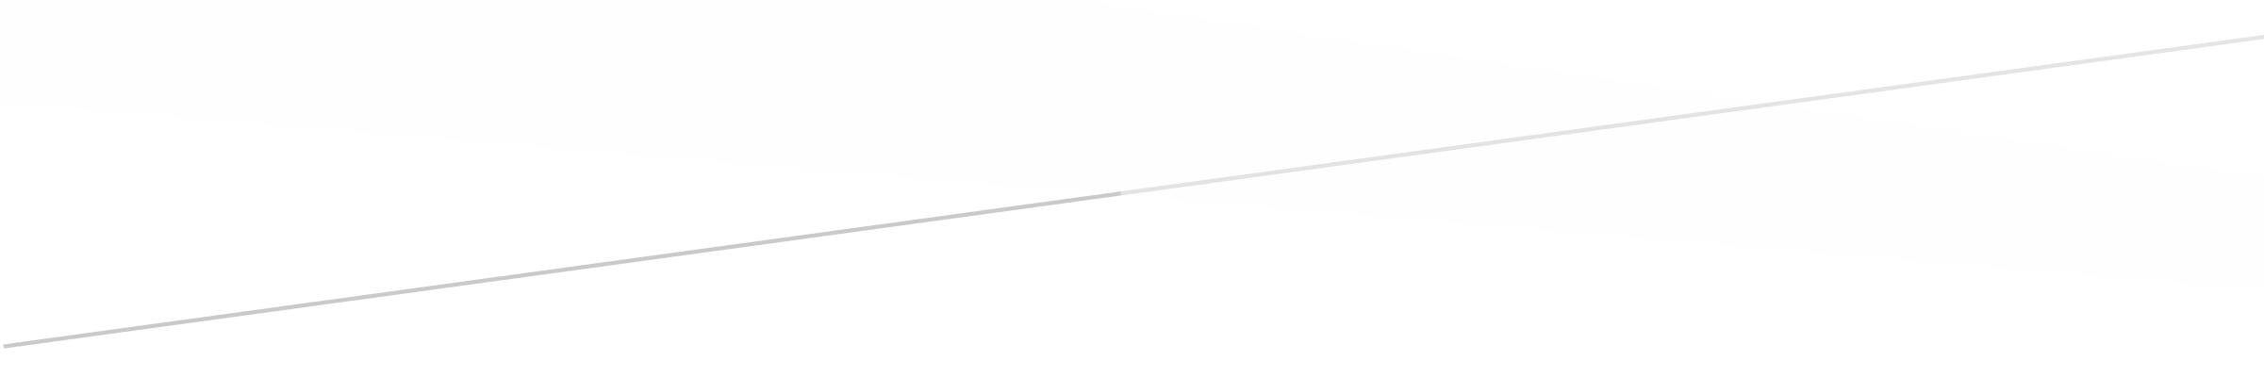

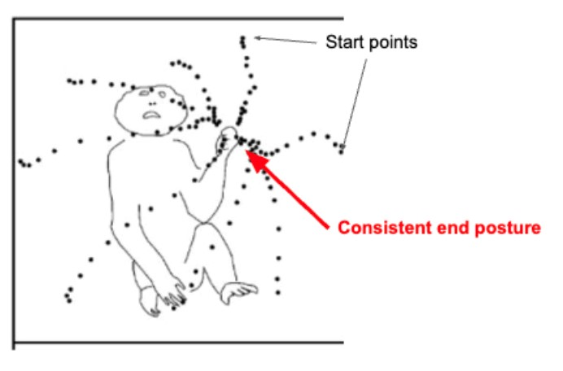

REACHING

Neural Data Analysis

Collaborated with Colin and Ian on this assignment – there is no differences compared to previous assignments, just forgot to put this statement on!

MATLAB project

Jaspreet Singh

# BEHAVIORAL DATA ANALYSIS

Similar to the Georgopoulos experiment in the 1908s, an experiment was done with macaque monkies to collect neural and behavioral data from the premotor area of MT motor cortex. The data was collected during a “delayed center-out” movement task. The task involved having the subject begin with their hands in a neutral central position and then they would reach their hand outward toward 8 different points, each located 45 degrees away from the center target. A signal to “go” was provided to the monkey so they would begin to initiate movement. A visualization of this schematic from the Georgopoulos experiment is provided below.

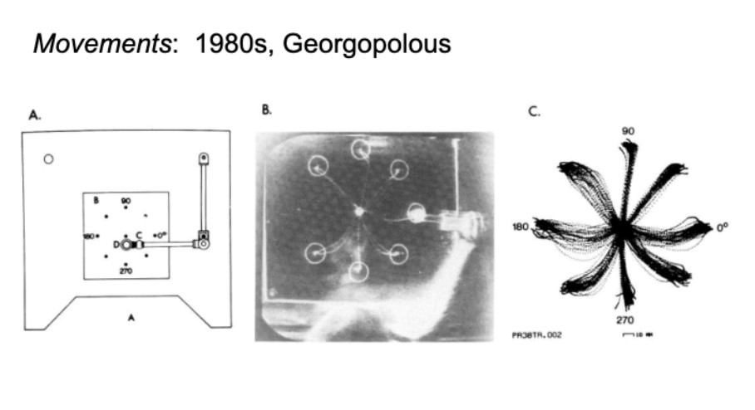

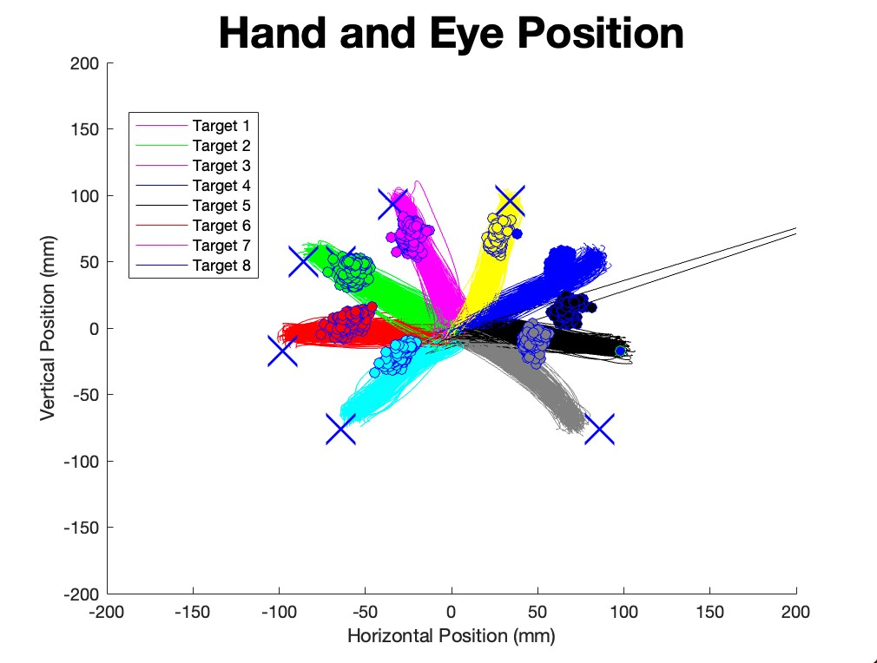

Using data collected during behavioral tasks, the movement of the monkey’s hand was plotted with eye position data. There is a total of 8 targets, which are denoted in the figure by distinct colors. The behavioral data, as mentioned before, comes from an experiment was done with macaque monkeys to collect neural and behavioral data from the premotor area of MT motor cortex. The data was collected during a “delayed center-out” movement task. The task involved having the subject begin with their hands in a neutral central position and then they would reach their hand outward toward 8 different points, each located 45 degrees away from the center target. A signal to “go” was provided to the monkey so they would begin to initiate movement. Eye position is color coordinated to align with the color of the hand position.

**Figure 1.** Figure 1 shows that each subject had to reach to one of eight targets in the periphery after a delay period. The different colors represent different target paths, the x at each of the 8 targets represents the true location of each of the 8 targets, and the filled circles represent the monkey’s eye movement during different trials, color coordinated by trial. The subject would initiate movement after being signaled with a cue to “go”. The actual targets are denoted by a red x in each of the eight locations of the targets; However, the subject’s hand movements to target were denoted by the filled circles near each target location above. The monkey performed well. There were two trials where the monkey did not move towards the appropriate target, as seen by the blue dots near target 6 ad 8. There is also an outlier in hand motion at target 7 (black).

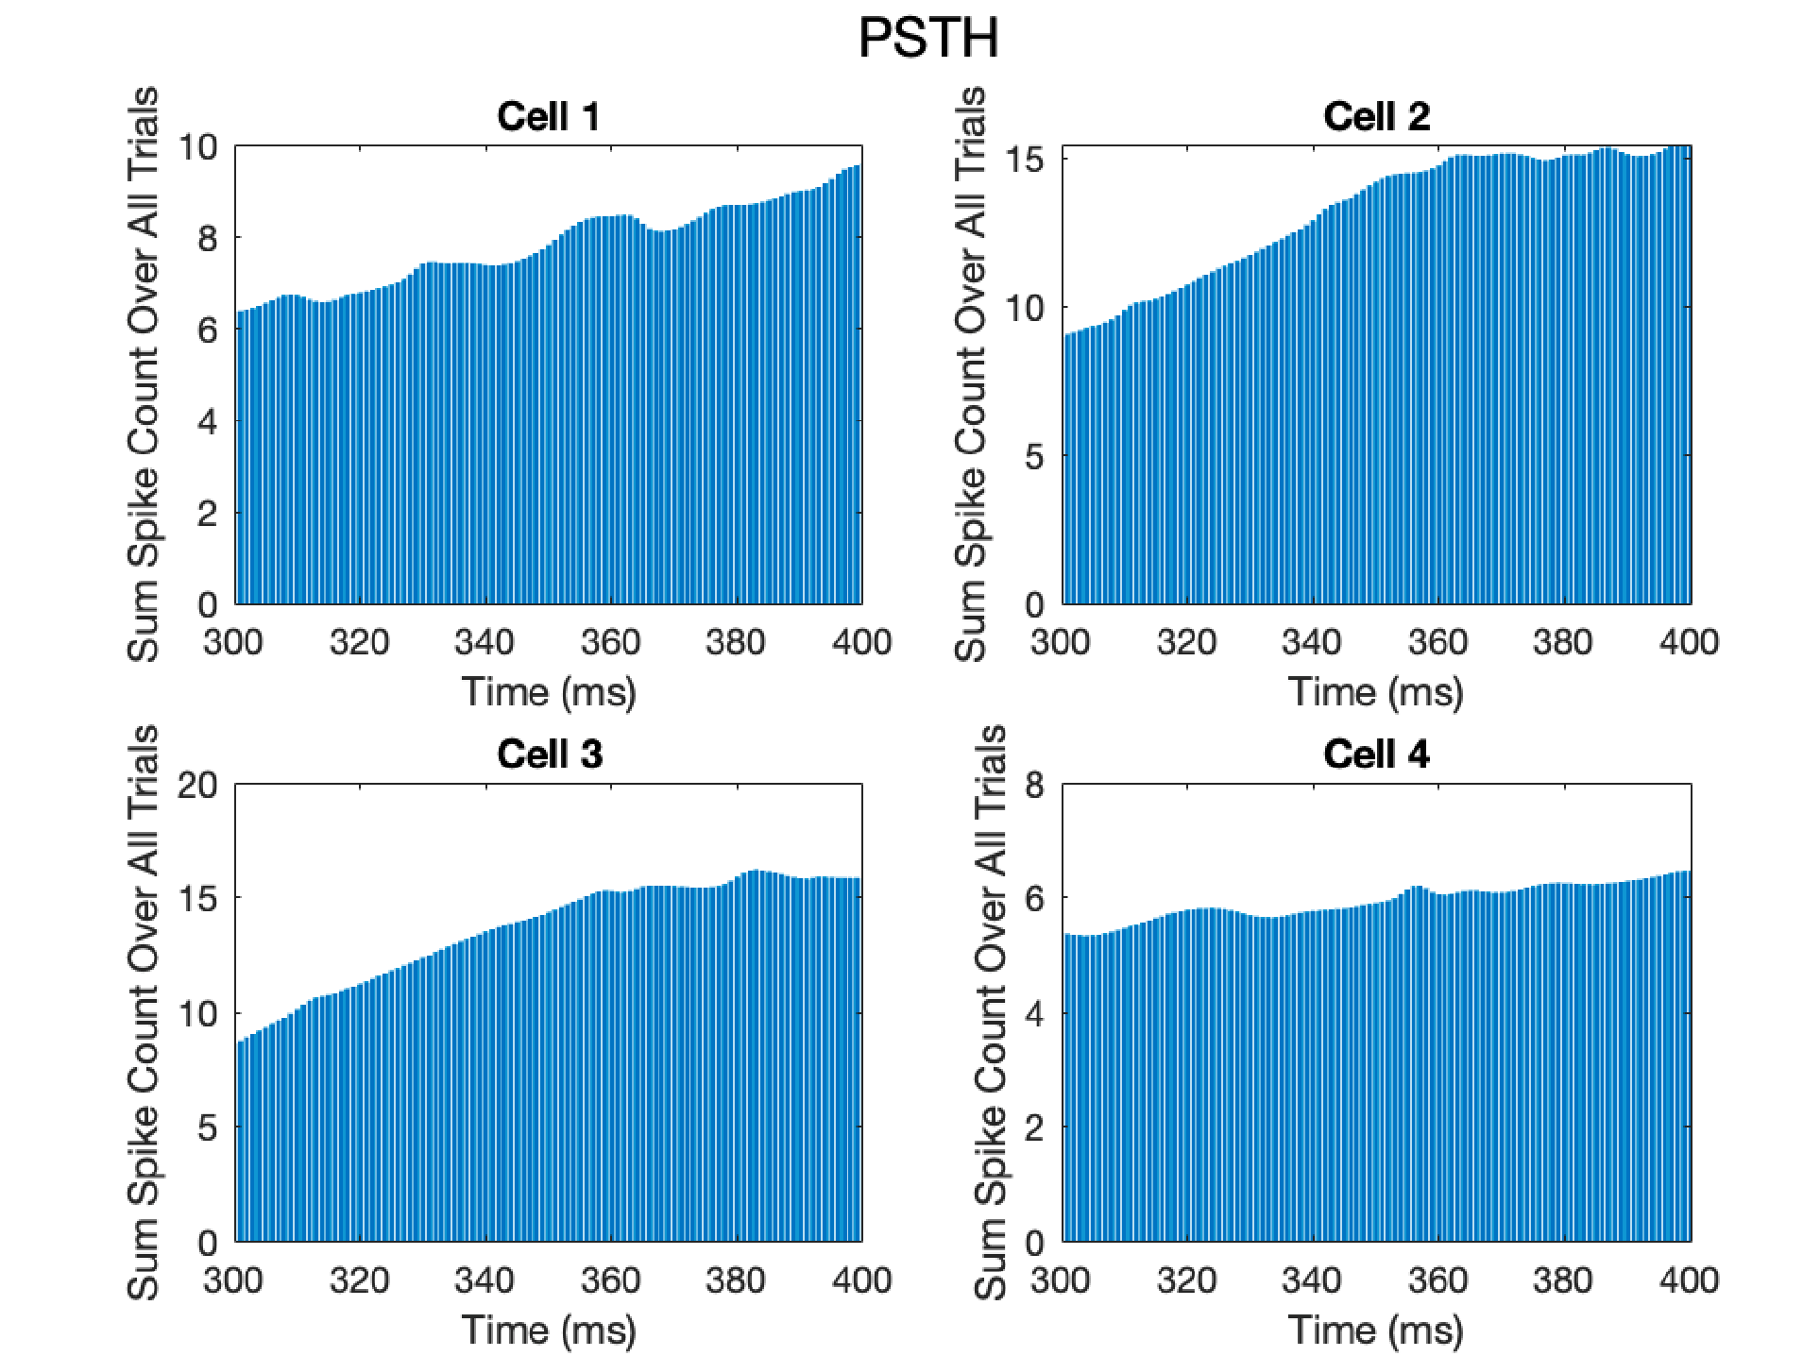

**Figure 2.1** To achieve maximal image resolution, binning was completed at 1 millisecond. PSTH have been made for the four cells where the target is in the upper right corner. Action potential spikes were summed for each trial from 300ms before the cue appears to 600ms after the cue appears. Shown here is from when the cue appears at 300ms to 400ms, with bin sizes of 1ms. Spikes during a 900ms window around the time of the cue appearing were summed for each cell for all trials where the target was in the upper right corner, with the results shown in a PSTH above.

PSTH Zoomed Out

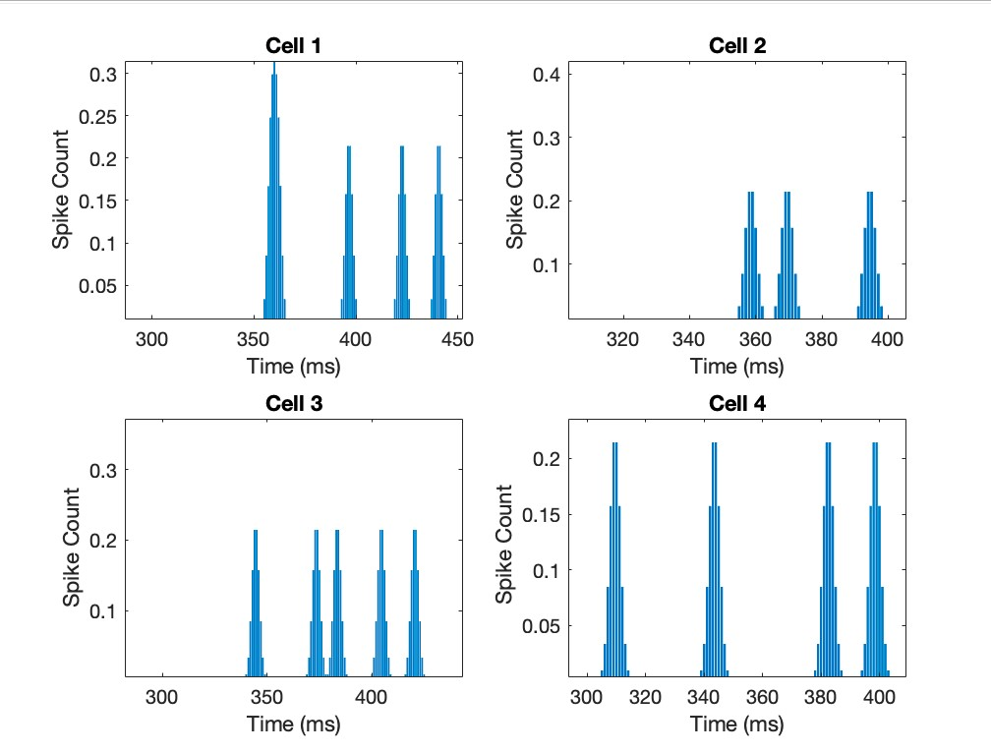

**Fig 2.2** The cue appears at and Cells 1 and 4 showed no change in the total spikes over each trial after the presentation of the cue, but Cells 2 and 3 show a clear increase after the presentation of the cue, with a latency of about 50ms. This could be due to the reaction time of the animal because it takes time to see, process, and react to stimuli. Additionally, we can see activity slightly before and after the cue in this zoomed out PSTH plot.

**NEURAL DATA ANALYSIS**

# Change in Velocity

**Figure 3.** Figure 3 shows the change in velocity of the monkey’s hand for 8 different trials of stimulus and response. The x-axis shows that the time over which the animal responds to the stimuli in milliseconds. The y-axis shows the velocity, or speed, of hand movement in response to the stimulus as millimeter/millisecond. The vertical lines show the monkey’s reaction time during the trial, calculated as the time where the monkey’s hand speed reaches 15% of the maximal speed. The reaction time appears to be faster during reaches to the upper right than other direction reaches. The monkey is being presented with a cue to go but the time it takes to display the stimulus has some display as the screen from the computer has a certain refresh rate, which was recorded, and the average latency was determined to be 18.9129 ms but the standard deviation of the latency was determined to be 4.8876 ms. This corresponds to the computer screen refresh rate being 57.84 Hz.

The mean and standard deviation of the reaction time associated for each of the eight targets and across all targets was calculated and is reported in the table below:

|  |  |  |  |  |  |  |  |  |  |
| --- | --- | --- | --- | --- | --- | --- | --- | --- | --- |
| **Trial**  **Number** | **1** | **2** | **3** | **4** | **5** | **6** | **7** | **8** | **Average across**  **Trials** |
| **Standard**  **Deviatio n Time per Target in milliseco**  **nds \*\*** | 23.88 63 | 19.91 77 | 21.95 98 | 19.96 57 | 20.66 84 | 22.472 7 | 22.660  8 | 21.440  6 | 21.6215 |
| **Mean**  **Reaction**  **Time per Target in milliseco nds\*** | 269.4 017 | 275.7 074 | 266.4 612 | 266.0 675 | 259.3 810 | 254.66 24 | 259.39 24 | 254.16 09 | 263.1543  13 |
| *mean reaction time per target is encoded as the variable mean_rt_t  ** standard deviation time per target is encoded as the variable std_rt_t) | | | | | | | | |  |

Table 1. The mean and standard deviation of the reaction time associated for each of the eight targets and across all targets was calculated and is reported in the Table 1.

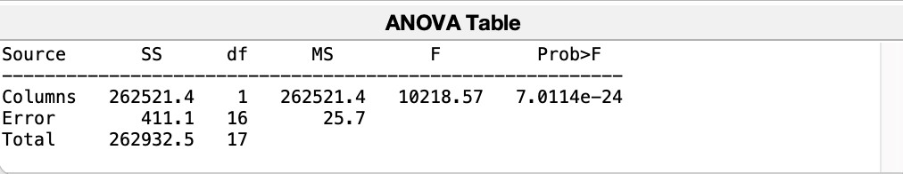

Table 2. An ANOVA test was performed, and the results are reported in the table above. The p-value is less than 0.05, indicating that there is a statistically significant difference among the means of the groups. Post-hoc analysis was completed using Tukey-Kramer test for all pairwise comparisons which reveals that there is a significant pairwise comparisons (p < 0.05):

Tukey-Kramer Pairwise Comparisons for all motion directions:

1.0000 2.0000 236.4676 241.5328 246.5980 0

This indicates there is preferential motion selectivity for the rightward direction, and that the animal subject has a bias towards moving faster to the right. Specifically, the upper right side.

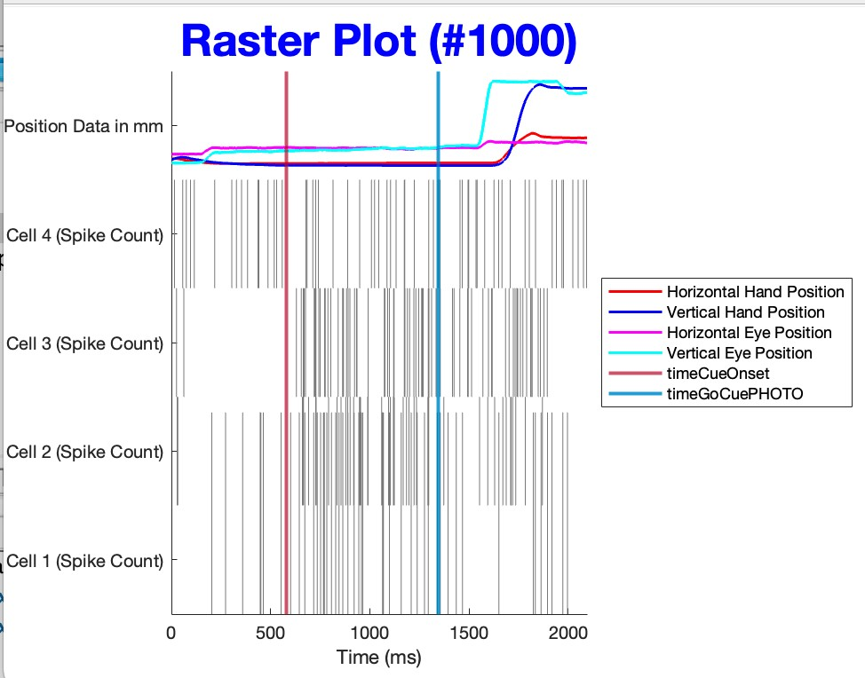

**Figure 4**. Figure 4 shows a peristimulus time histogram (PSTH) plotted for the four cells data was collected from in premotor cortex when the stimulus, or target, was presented to the subject at 45 degrees, or in the upper right direction. The PSTH were generated by adding the spikes from the trials occurring before the cue was shown the subject (300 ms before cue) to 600 ms after the cue was shown. The cells one and four show that there was no significant change after seeing the cue (no significant increase in raster spikes from the red to blue vertical lines). However, cells two and three show that there was a significant change and an increase in raster spikes in the same window. The red vertical line shows the onset of target and blue shows offset of target. However, the change in spikes occurs after a latency of 50ms which makes sense as there is a delay between the subject seeing the visual stimuli, sending signal to the brain, and then responding by reaching towards the stimuli. There is processing time of the stimuli and response time for the subject which accounts for this latency effect. Based on the lines above, eye position is noisier, as indicated by non-linearity hand and eye position.

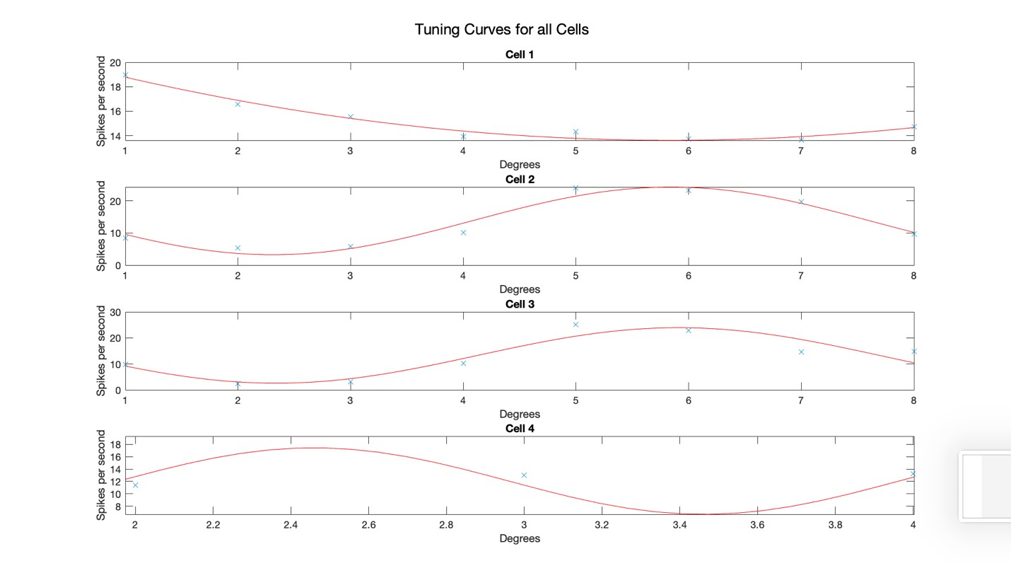

**Figure 5.** Figure 5 shows degrees versus spikes per second for the four cells data was collected from. For all four cells, the firing rates were fit as sinusoidal cosine as a function of each of the eight different target locations. To calculate this, first the firing rate was determined by spikes from onset of stimulus (visual cue) after accounting for delay times for processing of information until 600 milliseconds. Interestingly, the shapes of the curves align with the information from figure 4 suggesting directional selectivity for certain cells. Cells two and three show that firing rate (shown by the spikes per second) increase for a target in the upper right corner. However, cells one and four do not display the same pattern of behavior.